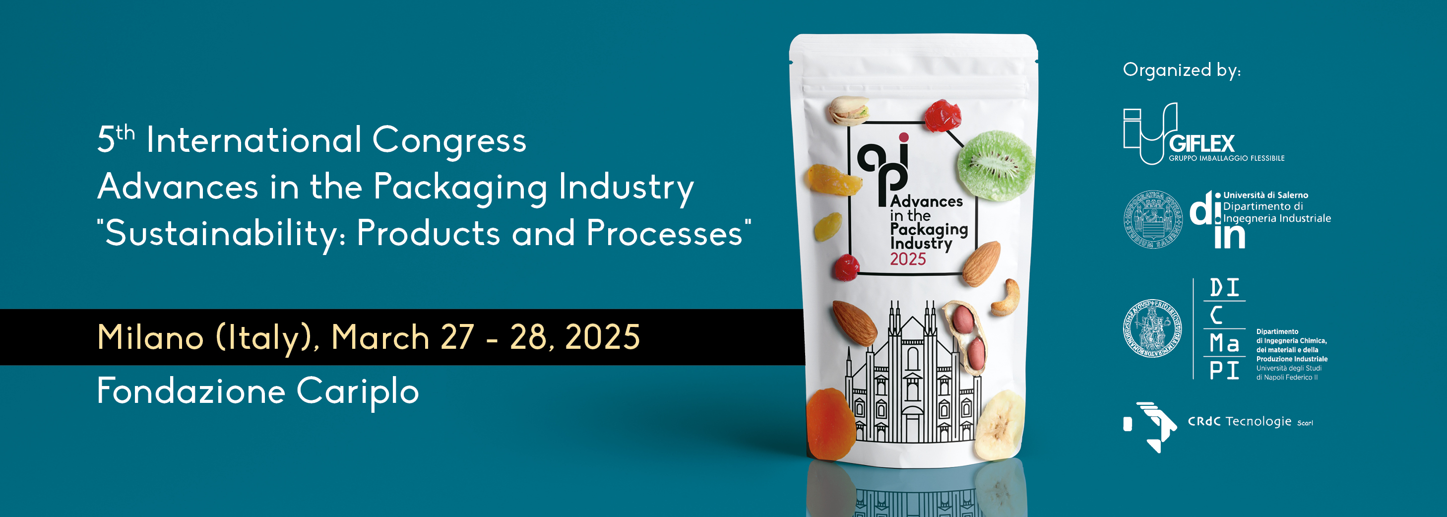

**Proceedings Publication on Zenodo**

**Authorization Form**

*To be sent by March 10, 2025*

*mcm@mcmcongressi.it*

The undersigned 

on behalf of all Authors authorizes the Scientific Secretariat of the 5th International Congress on Advances in the Packaging Industry to publish the full paper entitled:

-----------------------------------------------------------------------------------------------

in the **Congress Proceedings of the 5th API Congress**, deposited on the **Open Access** Zenodo platform (<https://zenodo.org/>).

For publication the organizers will consider the latest version of the Full Paper uploaded on the Congress website within the date of **January 31, 2025**. After this date the Paper cannot be changed any more.

In absence of this undersigned **authorization by March 10, 2025** the Paper will not be included in the Proceedings.

For acceptance

Name and Family Name 

Signature

